**Which agile software development method did your team decide to use and why? (0-10)**

In our project, we have decided to integrate both the Waterfall and Scrum methodologies to leverage their unique strengths and adapt to varying project demands. We use the Waterfall model for segments of the project where the requirements are well-defined and unlikely to change. This approach is particularly effective for foundational elements that demand rigorous documentation and precise adherence to initial requirements, providing a stable base for more dynamic project components.

Conversely, we apply the Scrum methodology to aspects of the project that are more fluid, where requirements can evolve based on ongoing user feedback or shifts in market conditions. Scrum's iterative cycles allow us to refine our project direction regularly, making adjustments and responding quickly through sprint cycles. This adaptability is crucial for fostering innovation and maintaining engagement with stakeholders.

By employing a hybrid model, we ensure that the structured progression of the Waterfall method underpins critical parts of our project, while the flexibility and rapid iteration of Scrum drive the development of features with more uncertain requirements. This strategic approach helps us balance the need for stability with the ability to adapt, reducing risks and enhancing the overall success of our project.

**Scrum meetings (or its alternative/equivalent): How frequently scrum meetings are conducted? (Date | Meeting Minutes or documentation attached?) (0-10)**

Generally, we schedule Scrum meetings twice weekly. One meeting is held on Teams and the other immediately after a regular lecture. On Teams, we typically meet at the beginning of the sprint to discuss what was completed in the previous week, evaluate if we achieved our goals as planned, and, most importantly, focus on the current week's objectives and our strategy to achieve them. So far, we have arranged meetings on Teams for the following dates:

May 17, 2024 (Team’s meet – to discuss project idea – 2 h 28 m);

May 21, 2024; (Team’s meet – to make project proposal on Canva – 2 h 1m)

June 10, 2024; (Team’s meet with mentor – 12 min – discussed what completed in sprint 1’s first week and what going to do in second half of that)

June 12 2024 (In person – planned what we will do in sprint 2 (reading week))

June 21, 2024 (Team’s meet – basic update from team members to know how far someone has achieved their individual task)

**The goal for each of the past sprints/iterations. (0-25)**

Until June 23, 2024, we have divided our time into two sprints. The first sprint spanned from June 3 to June 16 (two weeks). During this period, our team finalized the main objectives of our project, which initially had not been fully approved. We introduced new features and received approval from our mentor. Subsequently, we determined the workload and divided it equally: two members focused on the front end, two on the database, one on the backend, and one on testing. However, we decided to support each other across different areas as it is a team project, aiming to meet the requirements within the deadlines. This sprint involved developing a clear roadmap. Although we had a slow start, we focused on setting the correct trajectory, which required additional time.

The following sprint occurred during the reading week (17june – 23june). Our focus shifted to creating a clean and dynamic UI, setting up the basics of the backend and the database (MongoDB), and primarily focusing on data gathering and filtering. This was crucial as we were behind schedule in these areas during the first sprint. Our main priority was to complete this as soon as possible, with all team members concentrating their efforts to achieve this goal.

**How does the team divide the tasks among members? (0-10)**

In the Alpha Wave project, our team consists of six members, each specializing in different aspects of the development process to ensure a well-rounded and effective approach to the project. Two members of the team are dedicated to working on front-end technologies. They focus on designing and implementing the user interface, ensuring that it is user-friendly and aesthetically pleasing while maintaining functional performance. Another two team members specialize in database management, where their primary responsibilities include designing, maintaining, and optimizing the database to ensure data integrity and security, training model as well as efficient data retrieval.

Furthermore, one team member is tasked with backend development. he is responsible for server-side logic, integration of the front-end elements and ultimately making sure that the server, application, and database communicate with each other properly and efficiently. The final team member focuses on testing and reporting within project management. This role involves rigorous testing of the entire system to identify and resolve bugs or issues and preparing detailed reports on the testing results and project progress, which are crucial for maintaining and reporting the timeliness of the project’s development. This structured division of roles ensures that all aspects of the project are developed and managed effectively, and each team member contributes equally, ensuring that every aspect of the project is handled with the same level of commitment and expertise.

**The contribution of each member so far for each iteration/sprint. (0-10)**

We all have contributed completely equally all work and support each other and available for any point. To truly gauge the contribution of each team member for each iteration or sprint, we've implemented a thoughtful scoring system that considers both the quality and the quantity of the work each person delivers. We evaluate each member based on their specific roles and the overall impact their efforts have on advancing our project. It's crucial to acknowledge that each team member plays a vital role in our collective success, and though their contributions might differ in nature, each is equally important.

We don't just look at how well team members meet deadlines; we also consider our creativity, problem-solving skills, and ability to work cooperatively with others. These factors are essential in a collaborative environment like ours. This approach helps us ensure that every team member feels valued and motivated.

**Discussion on what went well, what went poorly, and opportunities for improvement to the product or ‘shipped’ process. (0-20)**

After our initial meeting with the mentor, which unfortunately did not go as planned since our project idea was not approved, we promptly organized a follow-up meeting on the same day. This additional session focused on identifying what went wrong and how we could effectively rework our project proposal. Although the initial feedback was disappointing, it ultimately provided us with a valuable opportunity to refine our concept, which aims to help retail stores manage empty shelves more efficiently.

During our subsequent meeting with the mentor, we took the chance to demonstrate the progress we've made since that setback. We discussed our efforts and improvements, showcasing that we have been diligently working to ensure that we are not only keeping pace with expectations but also striving to excel. This meeting was crucial in proving that we are on the right track and committed to our project's success.

Additionally, in our regular meetings, which include casual discussions and structured sessions, we explore various strategies to enhance our visibility and impact. We consider how we can best present our work to capture the interest of stakeholders and receive constructive feedback. These discussions often revolve around maximizing opportunities to demonstrate the quality and innovation of our work and getting insights from the General Assembly that could help us refine our approach and successfully meet all project deadlines.

**What is your team’s plan for the upcoming weeks? (0-10)**

For the upcoming weeks, our team has outlined a comprehensive plan to advance our project significantly across several key areas. We aim to achieve up to 70% completion of the UI development, focusing on developing a user-friendly and visually appealing interface. Alongside this, we plan to have the backend development reach 50%, ensuring that the core functionalities are properly set up and functional.

Additionally, we will be working on data binding, which involves labelling data effectively to ensure that the system can process and utilize it correctly. A crucial step in our schedule is the integration of the backend with the front end, which will allow us to start seeing how our application functions as a whole.

Lastly, we will focus on testing various aspects of the program that we've developed so far. This testing phase is critical as it helps us identify and rectify any issues early, ensuring the stability and efficiency of our application. Each of these steps is designed to keep us on track and make steady progress toward our project goals.

**What product backlog items are contributed toward the sprint/iteration goal? user stories should be written as the given template: As a < type of user >, I want < some goal > so that < some reason >.**

Sprint 1: Foundation

As a developer, I want to set up the project repository so that the team can start working on the codebase.

As a developer I want to know what are the backend APIs so that data can be fetched by the frontend

As a developer I want to store user’s data so that it can be stored permanently

As a developer I want to know how our application is going to look like so that it looks good to the end user

As a technical writer I want to document the application features so that users can understand how to use them.

As a user, I want to navigate the dashboard so that I can access different sections of the application.

As a user, I want to create an account so that I can access the application.

As a user, I want to log in so that I can use the application features.

Sprint 2: Development

As a data engineer, I want to collect raw data so that I can use it for data processing and analysis. As a data scientist, I want to augment the collected data so that I can improve the quality and quantity of data for better model training.

As a data annotator, I want to annotate the data so that it can be used to train machine learning models accurately.

As an end user, I want to access the initial homepage of the application so that I can start using the application.

As a full-stack developer, I want to integrate the frontend with the backend so that the application functions seamlessly.

As a backend developer, I want to implement the server and routes so that the application can handle client requests.

As a database developer, I want to create the database models so that the data can be stored and retrieved efficiently.

As a backend developer, I want to develop the user route so that the application can manage user-related operations.

As a QA engineer, I want to test the user route so that I can ensure it works correctly and handles user operations as expected.

As a backend developer, I want to develop the product route so that the application can manage product-related operations.

As a QA engineer, I want to test the product route so that I can ensure it works correctly and handles product operations as expected.

As a technical writer I want to document the application features so that users can understand how to use them.

**Tasks for each user stories. (0-25)**

Sprint 1: Foundation (2 weeks)

User Stories:

1. Decide which tech to use for combining Inventory Management system with ML model
2. Mind map of initial routes and development
3. Initial setup of the files/folder structure
4. Setup mongodb database
5. Frontend design using figma
6. Weekly report of the sprint

Sprint 2: Development (Currently running)

User stories:

1. Data Collection
2. Initial data augmentation
3. Initial Data Annotation
4. Initial homepage of the application
5. Integration of frontend and backend
6. Implementation of server and routes
7. Create the DB models
8. Develop the user route
9. Test the user route
10. Develop the product route
11. Test the product route

**Estimated value of story points/velocity. (0-25)**

Our team's velocity has been approximately **20 story points** per sprint, allowing us to effectively plan and manage our sprints based on historical data.

**Identified Risks and mitigation plan. (0-25)**

Risks:

1. Unavailability of a team member due to illness or any other problem.
2. API integration issues with third-party services.
3. Scope creep.

Mitigation plans:

1. Cross-training other team members to cover multiple roles
2. Allocate the time for proper testing and have contingency plans in place.
3. Priority backlog tasks first and use a change control process.

**The number of hours taken to complete each task. And a Screenshot of your task management board. (0-10)**

Sprint 1

1. Decide which tech to use for combining Inventory Management system with ML model – 2 hours
2. Mind map of initial routes and development – 3 hours
3. Initial setup of the files/folder structure – 2 hours
4. Setup mongodb database – 1 hour
5. Frontend design using figma – 8 hours
6. Weekly report of the sprint – 2 hours

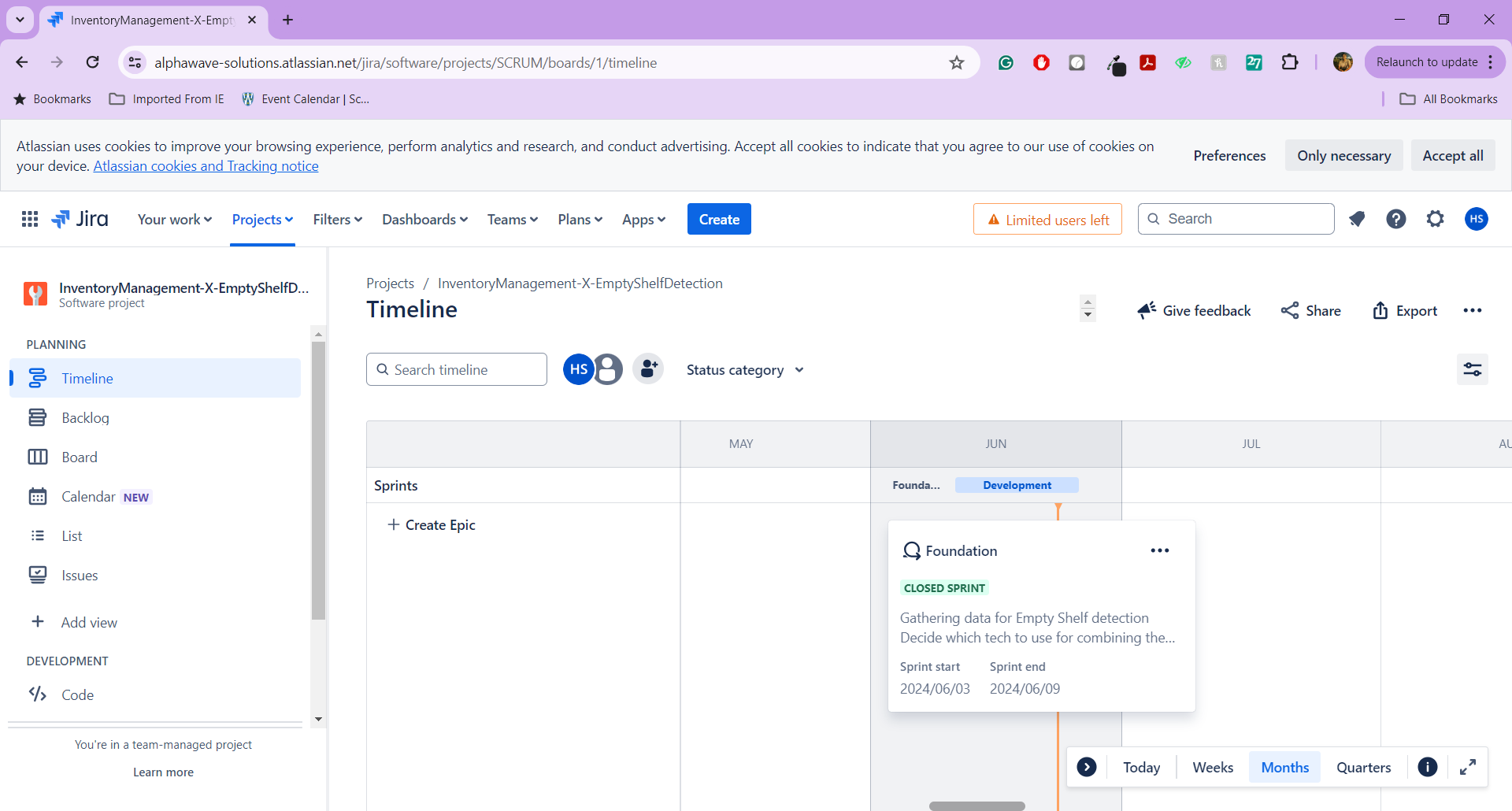

Sprint 2

1. Data Collection – 5 hours
2. Initial data augmentation – 8 hours
3. Initial Data Annotation – 10 hours
4. Initial homepage of the application – 4 hours
5. Integration of frontend and backend – 8 hours
6. Implementation of server and routes – 10 hours
7. Create the DB models – 2 hours
8. Develop the user route – 4 hours
9. Test the user route – 4 hours
10. Develop the product route – 4 hours
11. Test the product route – 4 hours

